Elkhorn

Whether you are picking up a racquet for the first time or just getting back into the swing of it, we are excited to share our passion for tennis and pickleball with you and your family. Regardless of age or ability, we have something for everyone this summer.

Elkhorn in Sun Valley

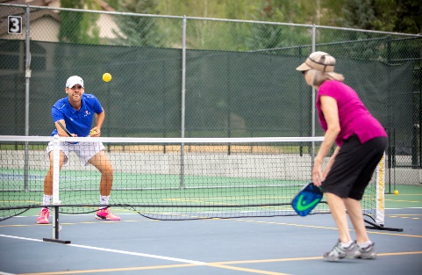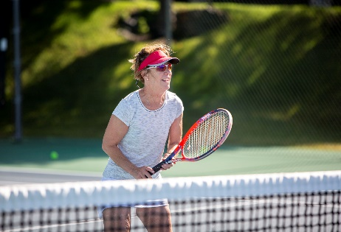

Racquet Sports 2022

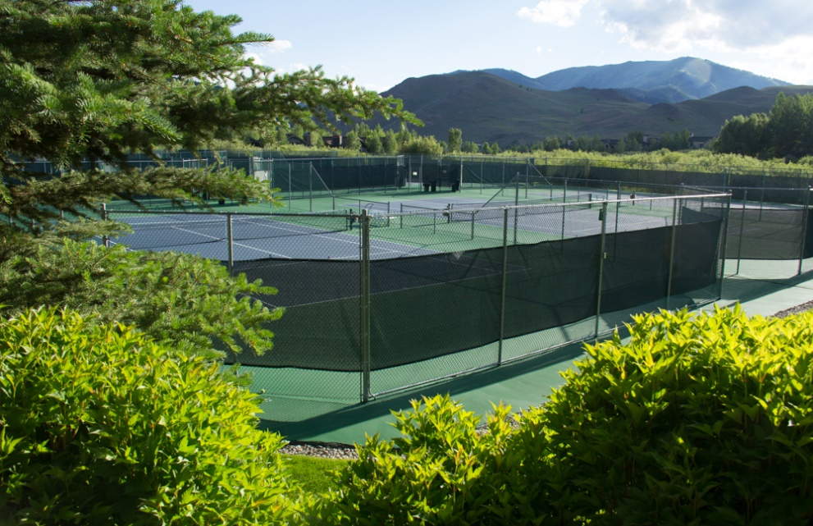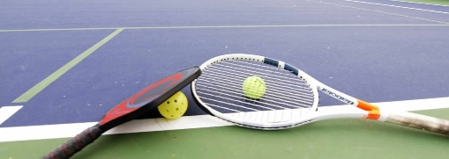

For the convenience of our property owners and guests all clinics and events are drop-in. We do, however, encourage players to sign up in advance as this helps management coordinate for additional staffing if needed. If clinics are attended by three or more players, clinics will run as normal. If below minimum attendance, instructor may substitute a private lesson. Ask Pro for details. **NO-SHOWS**: There is a cancellation policy for all lessons and court reservations. If you do not show for your scheduled lesson without contacting the Racquet Sports center 24-hours in advance, you may be responsible for the full rate of the scheduled lesson. If you fail to cancel your court reservation at least 8 hours in advance you may lose your reservation privileges.

RACQUET SPORTS Attendance Policy

***Staffing & Reservations***

***Harker Courts— (208) 622-9282***

*Jun 15 (TBD) to Sept 7, 2022 (2 Harker Lane)*

*Mon—Fri: 7:30 A.M. —4:30 P.M.*

*Sat & Sun: 8:00 A.M.—12:00 P.M.*

***Village Courts— (208) 622-5535***

*Jun 7 (TBD) to Sept 5, 2022 (102 Badeyana Dr)*

*Mon—Fri: 7:30 A.M.—4:30 P.M.*

*Sat & Sun: 8:00 A.M.—4:00 P.M.*

***Harker Offices— (208) 622-7420*** *(1 Harker Ln)*

*Mon—Fri: 9:00 A.M.—5:00 P.M.*

*Email: sveatennis1@icloud.com*

*Website: www.elkhorninsunvalley.com*

**Sign-in:**

***All players, at both the Village and Harker Courts, will be asked to present a valid amenity card. The amenity card allows players to check-in by scanning the barcode on the card at the check-in desks. Your cooperation in having your card available is greatly appreciated. If you need a card, please contact our administrative office and our staff will be happy to assist. Call: 208-622-7420***

**All players without a card and all non-resident guests will be charged a $5 access fee.**

**Organized Group Play Reservations for Tennis & Pickleball *may be made up to 30 days in advance. Reservations for organized group play is limited to no more than twice a* *week. Groups of no less than eight (8) may reserve either hard courts or soft courts. Half (50%) or more of all players listed on group rosters must be current Elkhorn property owners.***

**Tennis & Pickleball Court Reservations: *Property owners may make court reservations 72 hours in advance of play. Residents and guests may make court reservations up to 48 hours in advance.***

**Racquet Programs:**

***Exciting events are planned for 2022 and our racquet sports staff wants all owners and guests to get involved. Don’t be shy; if you do not have a regular tennis or pickleball partner or game, let the pros know and they will be happy to assist in introductions and help you get involved.***

Originally from Granville, NY, Scott has been the Director of Tennis at Windstar on Naples Bay for the past eight years.

Scott has been a member of one of the most recognized tennis management companies, Peter Burwash International (or “PBI”) from 2009-2017. Scott completed over 450 hours of on and off court training on his way to achieving an “Elite Professional” certification from the USPTA. In 2010, Scott was awarded the PBI Rookie of the Year Award in recognition of his abilities as an instructor.

Prior to working at the Windstar, Scott served in Head Professional and Director positions at Silverado Resort in Napa, CA, the Wyndham Rio Mar Beach Resort in Puerto Rico, and the Four Seasons Resort in Nevis, West Indies, among others.

As a player, Scott competed for Endicott College in Beverly, MA where he completed his Bachelor of Science in Sports Management. During his time there, he earned all-conference honors twice and was named team captain during his senior campaign.

Scott received his IPTPA certification as a qualified pickleball instructor in 2017 and was the winner of the 1st annual Sun Valley Pickleball Championship.

Off court, Scott completed an internship with the Massachusetts Special Olympics State Office where he helped organize statewide tournaments for soccer and equestrian.

**SVEA is Excited to Welcome Back Scott Teller for his Sixth Year as the On-site Racquet Sports Director for the Summer Season.**

Scott Teller

Racquet Director

Naples, FL

Sun Valley, ID

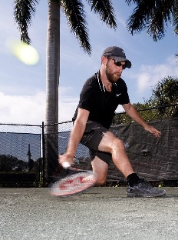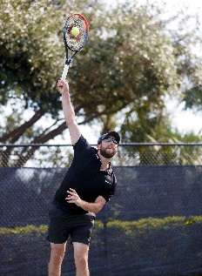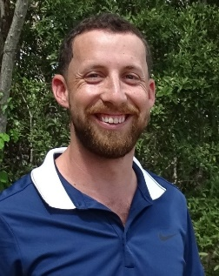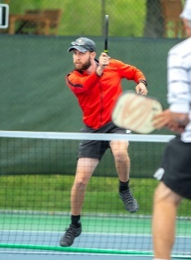

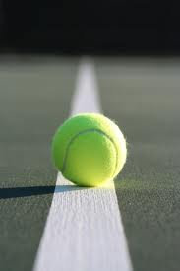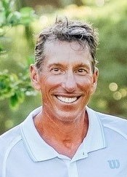

Donald Becker

Head Racquet Pro

Naples, FL

Sun Valley, ID

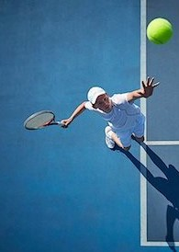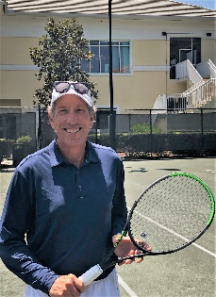

Donald joins Sun Valley Elkhorn Association with a world of experience gathered from coaching and directing tennis programs at many top-rated tennis resorts and clubs. He is a certified USPTA Elite Professional, PTR certified Professional, IPTPA Pickleball professional, and a graduate of the USTA High Performance Coaching Program.

Donald is originally from Buffalo, NY, where his love for tennis was nurtured early by his tennis playing family. After competing at Allegheny College, Donald went to work for the Town of Amherst Engineering Department Environmental Control Division, working in the field of water pollution prevention.

However, he continued his participation in the game, and eventually accepted the invitation to coach the Division I program at Niagara University. After several successful seasons coaching at the University, Donald accepted a full-time tennis club position where for the next seven years he directed a program at a club in Williamsville, NY, while also owning and operating a full-service pro shop.

Donald was the long time Tennis Director at Caneel Bay Resort on St. John, USVI and during his tenure there Caneel Bay was consistently ranked as one of the Top 10 tennis resorts in the world. He was also the Tennis Director at Hanalei Bay Resort on the Hawaiian Island of Kauai and most recently the Tennis Director at Naples Grande Beach Resort.

**SVEA is Honored to Welcome Back Head Racquet Pro, Donald Becker, to the Racquet Sports Program**

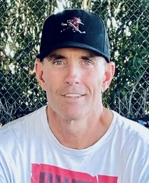

Originally from Indianapolis, Indiana, Brandon grew up in Scottsdale, Arizona.  He first played Pickleball as a kid in his backyard on a Sport Court.  Tennis eventually became his passion and he ended up serving as the Captain of the University of Arizona Team, earning wins over players ranked as high as #27 in the nation.  
 As a certified member of the USPTA, Brandon has extensive experience teaching Junior and Adult Tennis programs at several facilities in the Phoenix, AZ area. Pickleball came back into Brandon's life in 2018 when a friend from childhood told him he was playing in the National Championships. After watching the competition and picking up a paddle again for the first time since childhood, Brandon was hooked. When he turned 50 in 2021 he began playing Senior Professional Singles events on the APP and PPA Professional Pickleball Tours where he earned as high as the #16 spot in the World Pickleball Rankings, propelled by a Semi-Final appearance in the 2021 PPA Championships, a Pickleball Grand Slam Event.  In addition to his love for Pickleball competition, Brandon enjoys working with players of all abilities.  
 Prior to his arrival at SVEA, Brandon has served as the Head Pickleball Professional at Desert Highlands Racquet Club in Scottsdale, AZ and at Moon Valley Country Club in Phoenix, AZ.   
Off the courts you'll find Brandon in the gym training for his next tournament, searching for the best Vegan food wherever he goes, or spending time with his Mom and her Sharpeagle named Bear.

Brandon Hearn

Asst Racquet Pro

Scottsdale, AZ ~ Sun Valley, ID

Daniel Harden

Asst Racquet Pro

Naples, FL ~ Sun Valley, ID

Daniel is a USPTA certified tennis professional with over 10 years of full-time tennis instruction and experience.  Currently living in Naples, Florida and working at the prestigious Pelican Bay Foundation, he delivers a wide range of tennis experiences for players of all ages and skill levels.

Daniel Harden also has extensive experience running junior programs in both Tampa, Florida and Charleston, South Carolina.  In Tampa, he was the director of the Tennis Summer Camp at Palma Ceia Golf and Country Club for 5 years.  At Palma Ceia, Daniel also created a Team Tennis Junior League for his young tennis stars to compete against kids from other clubs.  In Charleston, he was the Director of Youth Tennis Development at Charleston Tennis Center.  Here he managed 15 courts of after school activities including: School practices and matches, daily junior clinics, challenge ladder matches, USTA and UTR junior tournaments, summer camp, and etc.

Daniel played college tennis at the Division 1 level at Georgia Southern University, in Statesboro, Georgia.  After college, he competed in Ultimate Tennis and won the league at the 6.0 level 6 times.  He also led his mens 9.5 combo doubles team to the South Carolina state title and his mixed doubles 9.0 team to the SC state finals.  Off the court, Daniel enjoys the beach, parks, spending time with friends and family, and all things sports and fitness.

Our 12-week Summer Tennis mixer will help you improve and play competitively with others of similar and improving abilities. Our tennis professionals will track your play each week and pair you with weekly challenging play. You may join the Mixer at anytime throughout the summer season; both men and women are invited to join! Please visit our website for registration details. Once registered you will receive and email confirmation for each day your are signed up to play.

https://elkhorninsunvalley.com/project/tennis-courts/

***Monday (2.5 Mixed Doubles) 8:00 – 10:00 A.M.***

***Wednesday (3.0-3.5 Mixed Doubles) 8:00 – 10:00 A.M.***

***Friday (4.0 Mixed Doubles) 8:00 – 10:00 A.M.***

**$15/day - Non-Resident Players (Includes $5 Access Fee)**

**$10/day - Tenants and Residing Guests**

**No Charge - Elkhorn Owners**

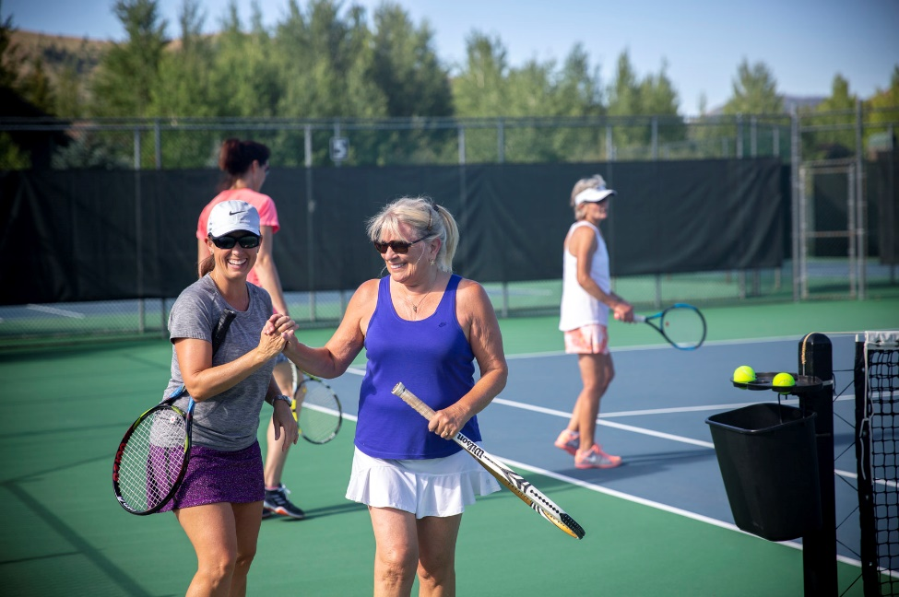

Summer tennis mixer

Jun 6 – Aug 26

ADULT TENNIS CLINICS

**At the Harker Courts ~ 2 Harker Ln ~ Sun Valley, ID**

**CLINICS ARE HELD FROM JUNE 6 TO AUG 20**

**FasTennis**

**Monday, Wednesday, Friday 9:30 A.M. – 10:30 A.M.**

This fast-paced tennis clinic is designed for men and women that want a great workout. Drills and point play make for a quick, fun drill session.

**One Hour Clinic** $35 – Non-residents (Includes $5 Access Fee)

$30 – Residing Guests & Tenants

$25 – Elkhorn Owners

**Skills & Drills**

**Monday, Wednesday, Friday 10:30 A.M. – 12:00 P.M.**

We will put our men and women through drills that replicate common match situations. Shot selection and court positioning will be emphasized through match play.

**90 Minute Clinic** $45 – Non-residents (Includes $5 Access Fee)

$40 – Residing Guests & Tenants

$35 – Elkhorn Owners

**Live Ball**

**Tuesday, Thursday, Saturday 10:30 A.M. - 12:00 P.M.**

This continuous flow, fast paced doubles style tennis game will be sure to give you a workout on the court! This class checks all the boxes, fun, fitness, action, and camaraderie!

**90 Minute Clinic** $45 – Non-residents (Includes $5 Access Fee)

$40 – Residing Guests & Tenants

$35 – Elkhorn Owners

**Daily Combo**

**Monday, Wednesday, Friday 9:30 A.M. – 12:00 P.M.**

Our tennis players have the option of combining both of our morning clinics. Get your sweat in with FasTennis and then work on common match situations with our Skills & Drills clinic.

**2.5 Hours of Clinics** $70 – Non-residents (Includes $5 Access Fee)

$65 – Residing Guests & Tenants

$55 – Elkhorn Owners

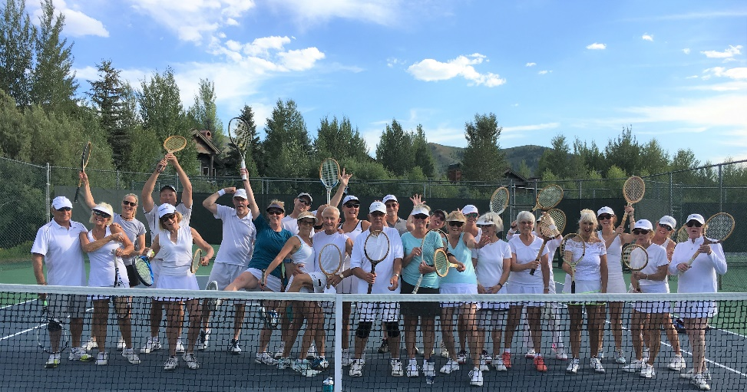

PRIVATE & GROUP RACQUET LESSONS AVAILABLE 7 DAYS A WEEK AT HARKER & VILLAGE COURTS

**Scott Teller | Donald Becker | Branden Hearn**

**Daniel Harden Lesson Rates**

(Tennis or Pickleball)

**1 Hour Private:**

$95 – Non-Residents (Includes $5 Access Fee)

$90 – Resident Guests and Tenants

$80 – Elkhorn owners

add $10 for additional player

**1 Hour, 3-4 players:**

$40pp – Non-Residents (Includes $5 Access Fee)

$35pp – Resident Guests and Tenants

$30pp – Elkhorn owners

**1.5 Hours, 3-4 players:**

$55pp – Non-Residents (Includes $5 Access Fee)

$50pp – Resident Guests and Tenants

$45pp – Elkhorn owners

ADULT PICKLEBALL

**At the Village Courts ~ 102 Badeyana Dr ~ Sun Valley**

**CLINICS ARE HELD FROM JUNE 6 TO AUG 20\***

**Pickleball 101 - New!**

**Mondays 9:00am – 9:30am**

This class is designed for those interested in Pickleball but do not know the rules and have never played the game. This class is highly recommended before signing up for the leveled clinics or social play.

$10 – Non-Residents (Includes $5 Access Fee)

$5 – Resident Guests and Tenants

Free – Elkhorn Owners

**Beginner Pickleball**

**Monday, Wednesday, Friday 9:30 – 10:45 A.M.**

Players new to the sport will learn a basic understanding of court positioning and strategy. Equipment is provided.

$17 – Non-Residents (Includes $5 Access Fee)

$12 – Resident Guests and Tenants

$ 8 – Elkhorn Owners

**Intermediate | Advanced Pickleball**

**Monday, Wednesday, Friday 10:45 A.M. – 12:00 P.M*.***

Our experienced pickleball players will compete against each other and learn advanced strategy from our certified professionals.

$17 – Non-Residents (Includes $5 Access Fee)

$12 – Resident Guests and Tenants

$ 8 – Elkhorn Owners

**Summer Pickleball Challenge**

**Saturdays 10:00 A.M. – 12:00 P.M.**

Join us for our weekly social where your SVEA pro's will pair you up for a fun and competitive morning of play! Scores will be tracked and each **week. Winners will be awarded a prize as well as the season high scorer at the end of the summer!**

Minimum 3.0 rating required to participate

$17 – Non-Residents (Includes $5 Access Fee)

$12 – Resident Guests and Tenants

$ 8 – Elkhorn Owners

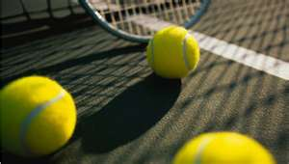

Held at the Harker Courts ~ 2 Harker Lane ~

June 20—Aug 12

Junior tennis

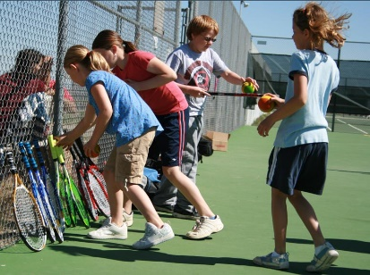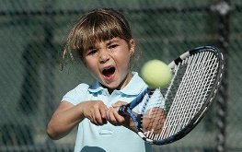

**Junior Tennis Ages 7 - 9**

**Monday thru Friday 9:00 A.M. - 10:30 A.M.**

Our aspiring tennis players will be shown strong fundamentals while being challenged with fun drills and games.

**90 Minute Clinic**

$35 – Non-Residents (Includes $5 Access Fee)

$30 – Resident Guests and Tenants

$25 – Elkhorn Owner’s Children

**Junior Tennis Ages 10 - 13**

**Monday thru Friday 10:30 A.M. – 12:00 P.M**.

Rallying, scorekeeping, and sportsmanship will all be taught and reinforced with fun, competitive drills, and games.

**90 Minute Clinic**

$35 – Non-Residents (Includes $5 Access Fee)

$30 – Resident Guests and Tenants

$25 – Elkhorn Owner’s Children

Pickleball Courts Installed 2019 | 2020 at the Village Racquet Facility

OTHER SERVICES

**Merchandise | Rentals | Stringing**

**RACQUET STRINGING & CUSTOMIZATION**

"Not sure if your racket is strung up properly to best suit your game? Have a broken string that needs repair? Or maybe just a simple grip replacement? Stop by the Harker or Village Racquet Center today to speak with one of our qualified professionals for stringing and racquet recommendations. All services guarantee 24-hr turnaround.

**SALES & RENTALS**

ProPenn Marathon High-Altitude Balls $5 / can

Onix Fuse G2 Pickleballs – $12 / 3 balls

Racquet & Paddle - $5 / day per person

Nike Baseball Cap - $30

